**SMART PARKING MANAGEMENT SYSTEM USING**

**IMAGE PROCESSING**

*EPICS PROJECT REPORT*

*Submitted by*

**ALAPATI RENUKA 208W1A1266**

**ANNAM JITIN CHAND 208W1A1271**

**JOY JEEVAN 218W5A1211**

*Under the Guidance of*

**G.GEETHA**

**Assistant Professor**

*For the award of the degree*

**BACHELOR OF TECHNOLOGY**

**IN**

**INFORMATION TECHNOLOGY**



**DEPARTMENT OF INFORMATION TECHNOLOGY**

**V R SIDDHARTHA ENGINEERING COLLEGE**

**(AUTONOMOUS - AFFILIATED TO JNTU-K, KAKINADA)**

**Approved by AICTE &Accredited by NBA**

**KANURU, VIJAYAWADA-7**

**ACADEMIC YEAR**

**(2022-23)**

**V.R. SIDDHARTHA ENGINEERING COLLEGE**

(Affiliated to JNTUK: Kakinada, Approved by AICTE, Autonomous)

(An ISO certified and NBA accredited institution)

Kanuru, Vijayawada – 520007

**CERTIFICATE**

This is to certify that this project report titled **“Smart Parking Management System using Image Processing”** is a bonafide record of work done by **ALAPATI RENUKA (208W1A1266),ANNAM JITIN CHAND(208W1A1271), JOY JEEVAN (218W5A1211)** under my guidance and supervision is submitted in partial fulfillment of the requirements for the award of the degree of Bachelor of Technology in Information Technology, **V.R. Siddhartha Engineering College** (Autonomous under JNTUK) during the year **2021-2022**.

**G.Geetha Dr. M. Suneetha**

Assistant Professor Professor & Head

Dept. of Information Technology Dept. of Information Technology

**TABLE OF CONTENTS**

ACKNOWLEDGEMENT iii

ABSTRACT iv

**CHAPTER-1 Introduction**  1

1.1 Origin of the Problem 1

1.2 Basic definitions and Background 2

1.3 Problem Statement with Objectives and Outcomes 4

1.4 Real time Applications of Proposed work 5

**CHAPTER-2 Review of Literature**  6

2.1 Description of Existing Systems 6

2.3 Summary of Literature Review 9

**CHAPTER-3 Proposed Method** 10 3.1 Design Methodology 10

3.2 System Architecture Diagram 11

3.3 Description of Algorithms 11

3.4 Description of datasets, Requirements and Tools 12

**CHAPTER-4 Results and Observations** 14 4.1 Stepwise description of Results 14

4.2 Test case results/Result Analysis 14

4.3 Observations from the work 16

**CHAPTER-5 Conclusion and Future work**  18

5.1 Conclusion 18

5.2 Future study 18

References 19

**ACKNOWLEDGEMENT**

First and foremost, I sincerely salute our esteemed institution **V.R SIDDHARTHA ENGINEERING COLLEGE** for giving me this opportunity for fulfilling my project. I am grateful to our principal **Dr. A.V.RATNA PRASAD**, for his encouragement and support all through the way of my project.

On the submission of this Project report, I would like to extend my honour to **Dr. M. Suneetha**, Head of the Department, IT for her constant motivation and support during the course of my work.

I feel glad to express my deep sense of gratefulness to my project guide **G.Geetha, Assistant Professor** for his guidance and assistance in completing this project successfully.

I would also like to convey my sincere indebtedness to all faculty members, including supporting staff of the Department, friends and family members who bestowed their great effort and guidance at appropriate times without which it would have been very difficult on my part to finish the project work.

**ABSTRACT**

With progressing urbanization and increasing availability of the cars another vehicles, inefficient parking has become a huge burden for drivers. This Smart parking system makes the whole process of parking cars more efficient and less complex for both drivers and administrators. Smart parking system uses Image Processing Techniques by taking real-time images via camera. The System can capture the circles which are plot at parking slot and containing the information of free car’s parking space. Camera can take the image that show occupancy of car parks and free parking slots. By having its image, the pointing car park empty space can be known rather than wasting time and wasting fuel to find the free slot. The demand for vehicles increases with the increase of the population. A densely replenished country like Bangladesh faces many challenges in managing this increased number of vehicles. Especially in city areas, where the road-side parking is not legitimate. Parking management can play an important role to diminish congestion on the roads. In our country, most of the parking areas are maintained by a manual parking system. In this paper, our aim is to design and develop a smart car parking system to solve the chaos, perplexity and long queues at the entry and exit of a parking space located inside public buildings including shopping malls and office spaces.

**Keywords**: Image Processing, Cvzone, Pickle.

**CHAPTER -1**

**Introduction**

It provides an overview of the project's goal, inception, and applications. It also outlines the project's requirement and scope, as well as showing project stoppers, which detail where the project is appropriate.

**1.1 Origin of the problem**

**1.2 Basic Definitions and Background**

**1.2.1 Adaptive Thresholding:**

Adaptive thresholding typically takes grayscale or color image as input and, in the simplest implementation, outputs binary image representing the segmentation. For each pixel in the image, a threshold has to be calculated. If the pixel value is below the threshold it is set to the background value, otherwise it assumes the foreground value.

There are two main approaches to finding the threshold: (i) the Chow and Kaneko approach and (ii) local thresholding. The assumption behind both methods is that smaller image regions are more likely to have approximately uniform illumination, thus being more suitable for thresholding. Chow and Kaneko divide an image into an array of overlapping subimages and then find the optimum threshold for each subimage by investigating its histogram. The threshold for each single pixel is found by interpolating the results of the subimages. The drawback of this method is that it is computational expensive and, therefore, is not appropriate for real-time applications.

An alternative approach to finding the local threshold is to statistically examine the intensity values of the local neighborhood of each pixel. The statistic which is most appropriate depends largely on the input image

**1.2.2 Morphology:**

Morphology is known as the broad set of image processing operations that process images based on shapes. It is also known as a tool used for extracting image components that are useful in the representation and description of region shape.

**1.2.2 Dilation:**

* Dilation expands the image pixels i.e. it is used for expanding an element A by using structuring element B.
* Dilation adds pixels to object boundaries.
* The value of the output pixel is the maximum value of all the pixels in the neighborhood. A pixel is set to 1 if any of the neighboring pixels have the value 1.

**1.3 Problem Statement with Objectives and Outcomes**

**1.3.1 Problem Statement:**

Drivers often encounter problems associated with locating empty parking slots in parking

areas. This paper presents a smart parking lot management system which operates using image processing. An image processing algorithm is used to detect empty parking areas from aerial images of the parking space. The algorithm processes the image, extracts occupancy information concerning spots, and their positions thereof. The system also reports if individual parking spots are occupied or otherwise. Occupancy information is made available to newly arriving drivers by projecting it unto large displays positioned at vantage points near the vicinity. The smart parking lot management system reduces the stress and time wastage associated with car parking and makes management of such areas less costly.

**1.3.2 Objectives:**

The smart car parking system is an integrated system to recognize the nearest

available parking zone. So, the main purpose of the system is to provide a solution to the parking problem, to reduce the time to search for parking lots, and to eliminate

unnecessary travel for vehicles.

**1.3.3 Outcomes:**

By the end of this work, we will have a model that can detect the occupied and vacant parking spaces and display the vacant slots that users can use for parking their vehicles.

**1.4 Real-time Applications of Proposed work**

With the rapid increases in the usage of vehicles in recent years, finding a parking area is more difficult, which leads to practical conflicts such as traffic congestion. A solid system is used to identify a free slot in a parking area and keep the record of vehicles which are parked. It is very useful for the drivers to find a free slot before they reach their destination. In this system, we identify the free slots, a vehicle is identified using image processing.

**CHAPTER-2**

**Review of Literature**

This literature review primarily focuses on the materials that assisted us in grasping an ideology of the image processing and classification techniques research field. The research articles described in depth how various algorithms and frameworks might be used to classify data.

**2.1 Description of Existing Systems**

This section primarily focuses on research publications, covering the paper's primary details. It contains the findings and conclusions from each study**.**

**2.1.1** **A Multi-storey Garage Smart Parking System based on Image Processing , 2019.**

**Authors:** Chyn Ira C. Crisostomo, Royce Val C. Malalis, Romel S. Saysay, Renann G. Baldovino

**Observations:**

In this study, an image-processing based smart parking system was developed for multi-storey parking garages. Car drivers spend a considerably long amount of time finding an available parking space where slots are spread throughout multiple storeys which causes longer queues and traffic congestion. The proposed system design through the Python IDLE and the OpenCV library makes use of the combined edge detection and coordinate bound pixel sections in determining whether a parking space in the acquired footage is occupied or not. For the testing of the accuracy and reliability of the parking space identification system, sample footages of actual indoor parking garages were used. With this study, real time image processing and updating of the parking slot availability offers an increased efficiency to the parking system and lower cost than installing individual car sensors in each parking space.

**2.1.** **Identification of Parking Lot Status Using Circle Blob Detection**

**Authors:** Mohammad Nasrul Mubin , Hendra Kusuma, Muhammad Rivai

**Year of publishing:** 2021

**Observations:**

Information on the availability of parking spaces, especially in large parking areas, is needed by parking users. This information will help users in terms of saving search time, effort, and fuel (money). Currently, parking space detection methods are divided into image detection and non-image detection methods. Non-image detection is not completely good, even some of its implementations require demolition of roads or buildings. In addition, the maintenance required for non-image detection can be more expensive, so the image detection method was chosen in this study. The system is designed by first converting the image into the HSV color space. The conversion image is then given the CLAHE process on channel V of HSV. The next step is to transform the image dimensions with perspective transformation in the area which is the parking lot slots. The transformed image covers the parking slots that will be detected. Then, from the transformation image, the status of each parking lot slot is detected by utilizing the auxiliary circle in each slot. The results of this process are then shown as the availability information for parking space users. The results of the identification trial of this system showed a great success rate of 99.28%.

**2.1.****3** **Car Detection in Roadside Parking for Smart Parking System Based on Image Processing , 2018**

**Authors:**Kowshik B, Nimosh madhav M, Karpagam G, Savitha V

**Year of publishing:** 2021

**Observations:**

This study aims to detect vehicles that are on the side of the parking lot so that it can be used as a smart parking system for parking management and find out information on the availability of parking spaces. In this study, the authors used the Haar Cascade Classifier, and YOLOv3 then compared them to get the best accuracy in detecting parked cars. The test was carried out using ten different scenarios, the highest accuracy obtained in this study was 96.88% using YOLOv3 with a probability of 90%. In contrast, the accuracy obtained by using the Haar Cascade Classifier is 63.34%.

**2.1.4 Intelligent smart parking algorithm, 2017**

**Authors:** R. Sujatha , Jyotir Moy Chatterjee b , NZ Jhanjhi , Sarfraz Nawaz Brohi

**Year of publishing:** 2021

**Observations:**

In this paper, we will be discussing about the parking system in a city which is embedded with various features like automated, rotary parking and nearest parking slot allotment using IoT and sensor technology. As we know that parking is one of the major problems especially in cities due to lack of required amount of parking area, maintenance facility and lack of proper guidance to park the car. Also there are situations which lead to chaos between people due to lack of proper guidance between them while travelling in the parking area to park the car. In this, we will be providing an algorithm which provides an effective and efficient solution to park the car by using hybrid parking mechanisms to provide more parking efficiency and cost effective with less maintenance and power consumption. Here, we will be using the CMOS sensors for number plate identification, speed sensors for speed detection, ultrasonic sensors for vehicle detection, softwares working OCR, arduino as a microcontroller and Raspberry Pi to interface all the components. The paper focuses on the effective and efficient smart working methods along with guided user safety.

**2.2 Summary of Literature Study**

We have determined in this chapter that deep learning algorithms outperform machine learning techniques. In addition, the frameworks used are sophisticated, thus training a model takes longer. This research concluded that a methodology that takes less time to teach and a framework that is less hard to develop is required. We discovered that the methods previously proposed require more time to train a model. The complex frameworks also made model construction more difficult. In order to maintain data privacy, we must also have a methodology in place.

**CHAPTER-3**

**Proposed Method**

This chapter focuses on a procedure for identifying plant leaf disease that produces excellent results.

**3.1 Design Methodology**

1. The system will get live stream video of the parking lot from camera.
2. Images are captured when a car enters the parking lot.
3. RGB Images are converted to binary images.
4. The frame is cropped lane wise and considered sequentially and individually in a loop.
5. Vacant slots with their respective lane is known by calculating the number of cars.

**3.2 System Architecture Diagram**

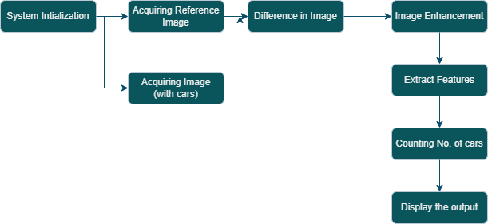

**3.3 Description of Algorithms**

**Algorithm**

* For image segmentation:
* Adaptive Thresholding –a technique of image thresholding is used
* Dilation – Morphological Operation
* CountNonZero() function for counting of pixels

**3.4 Description of datasets, Requirements and Tools**

**3.4.1 User Interface:**

This system's user interface is the PyCharm, which is a user-friendly Python Graphical User Interface.

**3.4.2 Hardware Interfaces:**

Python capabilities are used to allow the user to interact with the console.

**3.4.3 Software Interfaces:**

Required modules (Numpy, OpenCv, Cvzone, Pickle) have been imported into the Python environment.

**3.4.4 Hardware Requirements:**

1. Processor – Pentium-IV
2. RAM – 4GB (Minimum)
3. HDD/SSD – 256GB (Minimum)

**Chapter-4**

**Results & Observations**

**4.1 Stepwise description of Results**

1. The system will get live stream video of the parking lot from camera.
2. Images are captured when a car enters the parking lot.
3. RGB Images are converted to binary images.
4. The frame is cropped lane wise and considered sequentially and individually in a loop.
5. Vacant slots with their respective lane is known by calculating the number of cars.

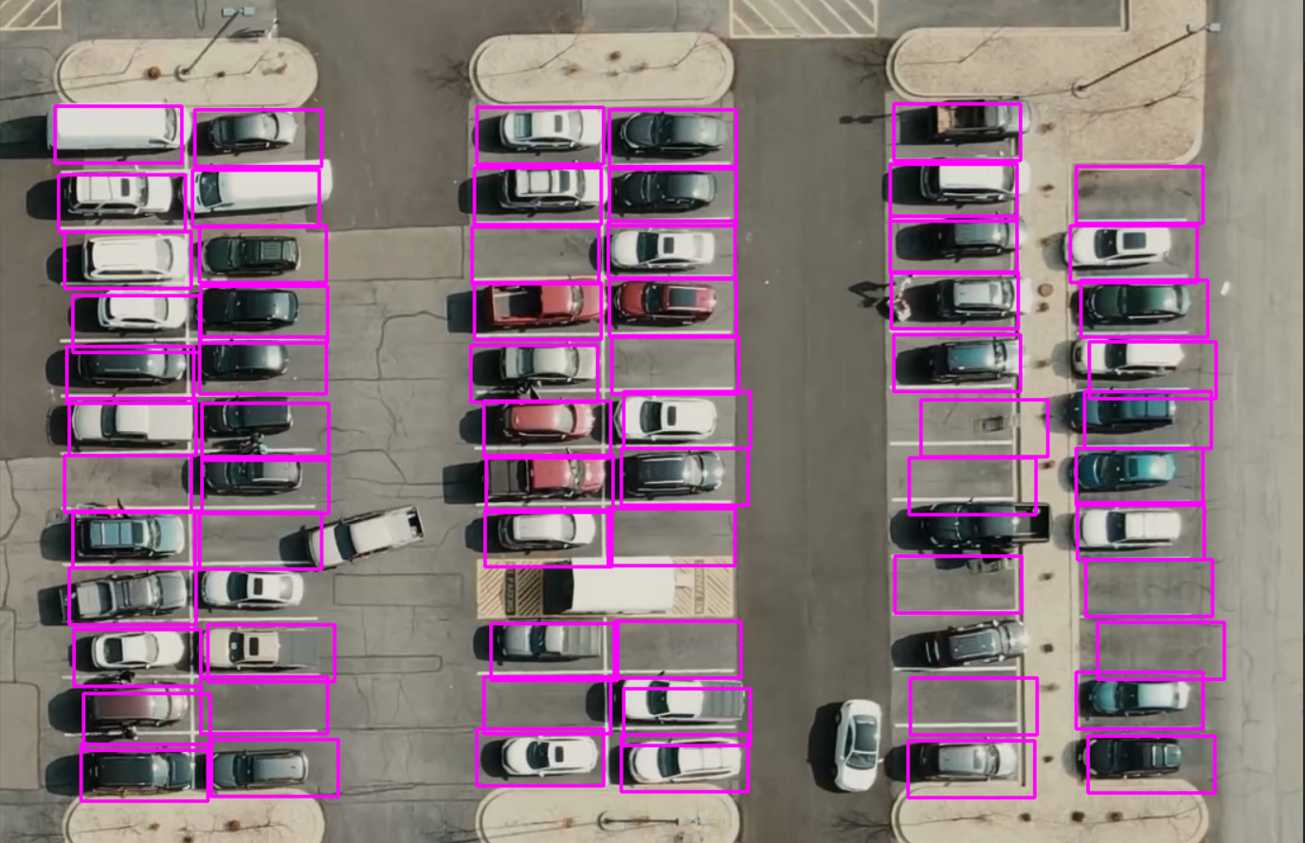

**4.2 Test case results**

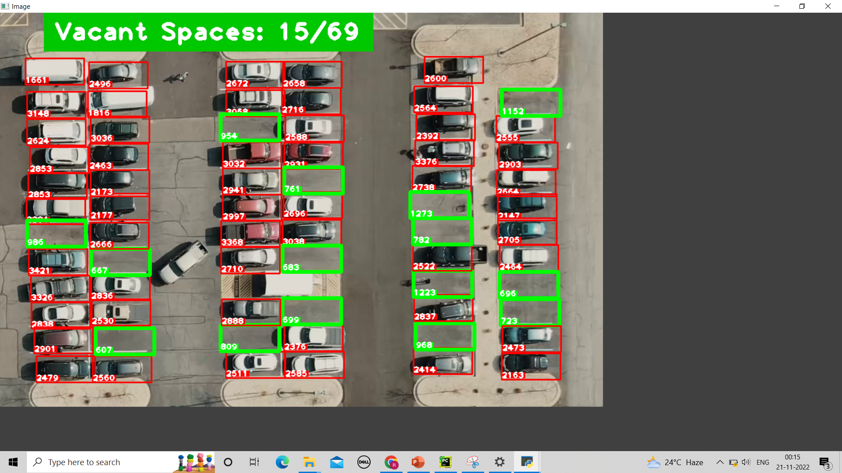

**CHAPTER-5**

**Conclusion and Future work**

**5.1 Conclusion**

An image-processing based smart parking system was developed for multi-storey parking garages. Car drivers spend a considerably long amount of time finding an available parking space where slots are spread throughout multiple storeys which causes longer queues and traffic congestion. The proposed system design through the Python IDLE and the OpenCV library makes use of the combined edge detection and coordinate bound pixel sections in determining whether a parking space in the acquired footage is occupied or not. For the testing of the accuracy and reliability of the parking space identification system, sample footages of actual indoor parking garages were used. With this study, real time image processing and updating of the parking slot availability offers an increased efficiency to the parking system and lower cost than installing individual car sensors in each parking space.

**5.2 Future Study**

* Smart Parking Management System (SPMS) is used to book parking slots without any great effort by the user using an android device. The user can check the status of parking area and book the parking slot in advance. This will result in overcoming many problems which are being created due to the bad management of the traffic. Mobile computing has proven as the best area of work for researchers in the areas of database and data management so this application is applied in Android OS.

**References**

[1] Abhirup Khanna and Rishi Anand, "IoT based smart parking system", *2016 international conference of IoT and applications*.

[2] Sagar Rane, Aman Dubey and Tejisman Parida, "Design of IoT Based Intelligent Parking System Using Image Processing Algorithms", *2017 International Conference on Computing Methodologies and Communication*.

[3] Mechkul Jayakshei Dadaji Bachhava, "Smart Car Parking System", *International Research Journal of Engineering and Technology (IRJET*, vol. 04, no. 06, June 2017.

[4]K. Karthik, A. Sridevi and C. Vivek, "Image processing based intelligent parking system", 2017 IEEE International Conference on Electrical Instrumentation and Communication Engineering (ICEICE), 2017.

[5] Z. Ji, I. Ganchev, M. O'droma and X. Zhang, "A cloud-based intelligent car parking services for smart cities", General Assembly and Scientific Symposium (URSI GASS) 2014 XXXIth URSI, pp. 1-4.

**DEPARTMENT OF INFORMATION TECHNOLOGY**

**V.R. SIDDHARTHA ENGINEERING COLLEGE**

**PROJECT SUMMARY**

|  |  |  |
| --- | --- | --- |
| S.No | Item | Description |
| 1 | **Project Title** | **Smart Car Parking Management System** |
| 2 | **Batch Names & Numbers** | **A. Renuka (208W1A1266)**  **A. Jitin Chand(208W1A1271)**  **T. Joy Jeevan (218W5A1211)** |
| 3 | **Name of The Guide** | **G. Geetha** |
| 4 | **Name of The Mentor** | **G. Jayalakshmi** |
| 5 | **Research Group** | **Image Processing, Computer vision** |
| 6 | **Application Area** | **Traffic Control** |
| 7 | **Aim of the Project** | **Finding the vacant parking slots** |
| 8 | **Project Outcomes** | **The goal of this work is to create a system capable of detecting and identifying the vacant parking slots so that we can show vacant slots to the driver.** |

**Student Signatures**

1. **A. Renuka**
2. **A. Jitin Chand**
3. **T. Joy Jeevan**